**A COMPREHENSIVE ANALYSIS OF FINANCIAL PERFORMANCE:INSIGHTS FROM A LEADING BANKS**

**INTRODUCTION:**

**Overview:**

The banking industry world-wide is being transformed. The global forces for change include technological innovation; the deregulation of financial services at the national level and opening–up to international competition ; and – equally important- changes in corporate behaviour , such as growing disintermediation and increased emphasis on shareholder value. In addition , recent banking crises in Asia and Latin America have accentuated these pressures .The banking industries in Central Europe and Latin America have also been transformed as a result of privatizations of state-owned banks that had dominated their banking systems in the past. IN this project we are trying to analysis the bank related data and able to extract some insights from the data using Business Intelligence tools. To extract the insights from the data and put the data in the form of visualization , Dashboards and story .

**PURPOSE:**

This analysis is useful for avoiding financial risks.It provides financial information such as the company’s asset structure , asset liquidity , source of funds, debt level and liability structure.

**PROBLEM DEFINITION AND DESIGN THINKING:**

**EMPATHY MAP:**

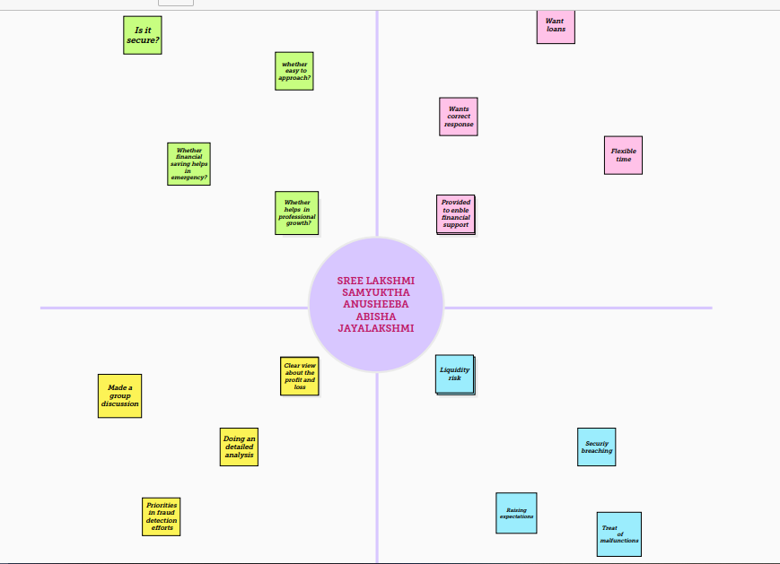

**IDEATION AND BRAINSTORMING MAP**

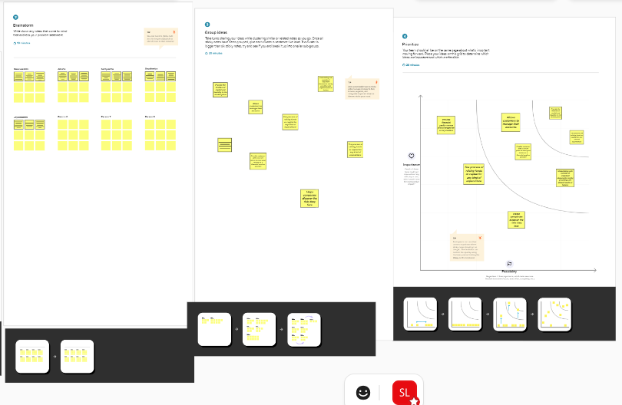

**RESULT:**

We created the data visualization such as dashboard and story using the dataset provided.

DASHBOARD:

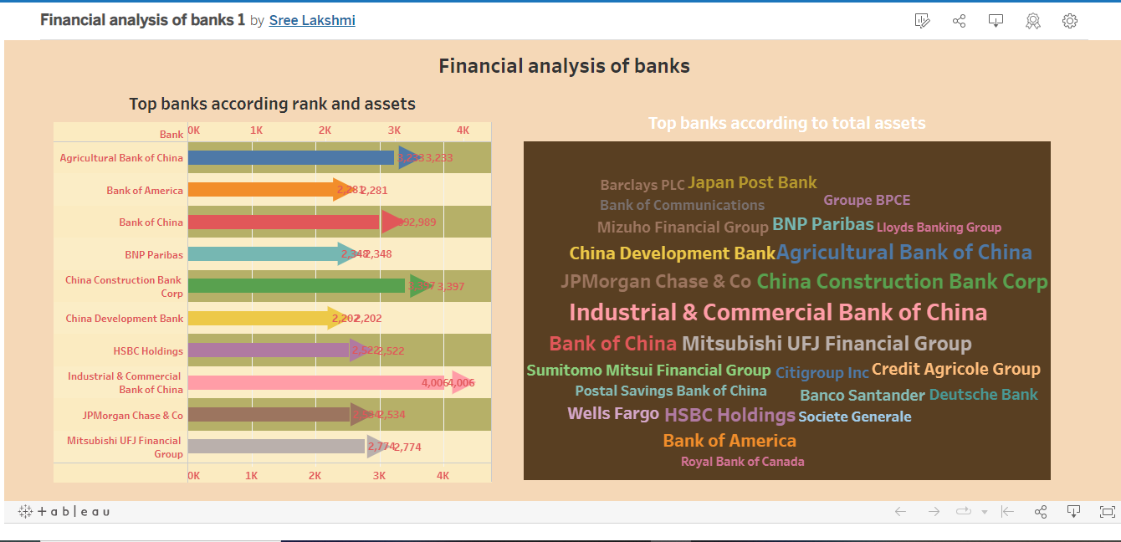

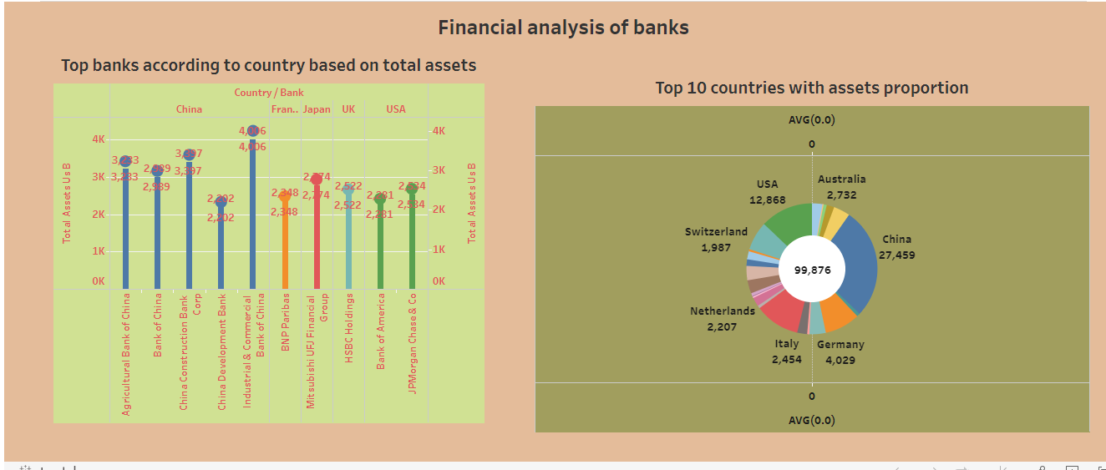

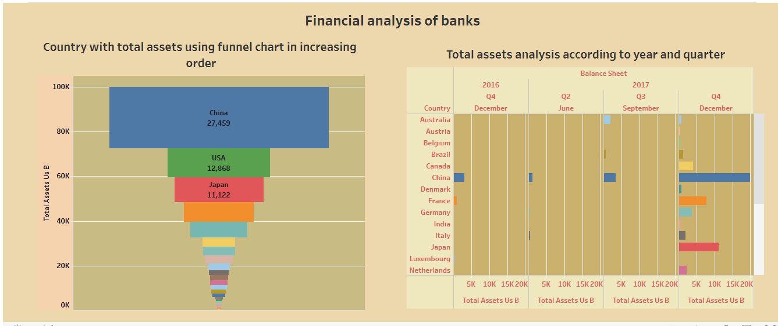

STORY:

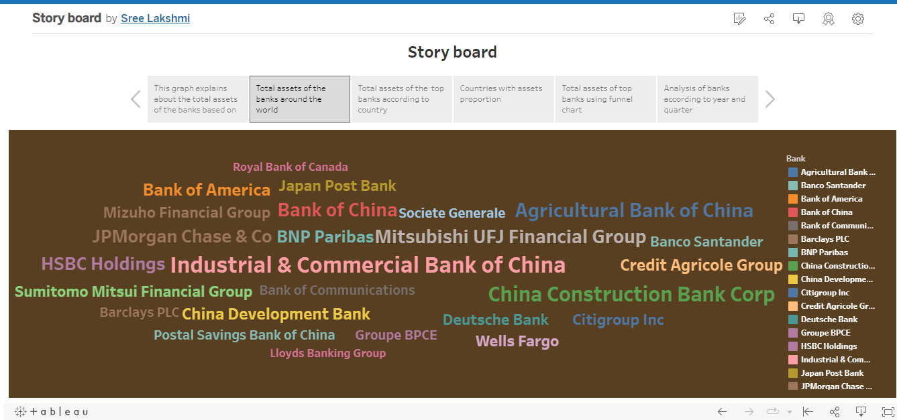

**ADVANTAGES AND DISADVANTAGES:**

ADVANTAGES:

* The ability to detect patterns. Financial statements reveal how much a company earns per year in sales.
* A company’s financial performance tells investors about its general well- being.

DISADVANTAGES:

* The financial analysis does not contemplate cost price level changes.
* Loans are not very flexible

**APPLICATIONS:**

The evaluation of past financial performance, the projection of future financial performance ,the assessment of credit risk and the screening of potential equity investments. It is used to identify and rate individual customers who are at risk of fraud and then apply different levels of monitoring and verification to those accounts.

**CONCLUSION:**

Analysis of financial statement is extremely important for every business to grow an dincrease their revenue. And in this project we learned to prepare the data visualization based on the data collected. The work we did in this project helped us to understand the performance without much difficulty and also understand how to prepare them in future.

**FUTURE SCOPE:**

It provides financial performance such as the company’s asset structure ,asset liquidity, source of funds, debt level, and liability structure. Thus it is useful for avoiding financial risks.